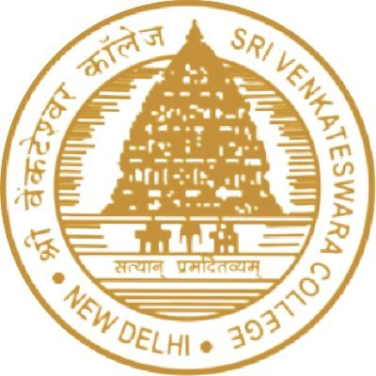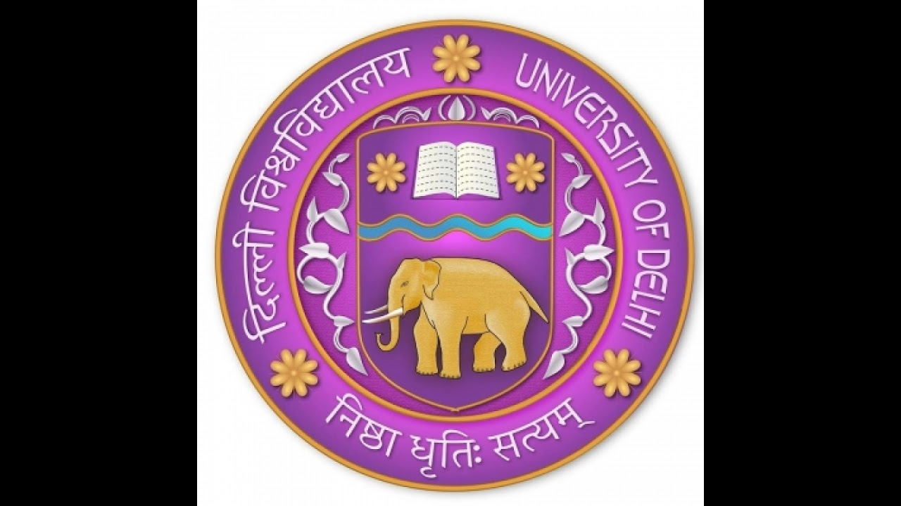

**SRI VENKATESWARA INTERNSHIP PROGRAM**

**FOR RESEARCH IN ACADEMICS**

**(SRI-VIPRA)**

**Project Report of 2024: SVP-2431**

“Job Assistant Chatbot”

**IQAC**

**Sri Venkateswara College**

**University of Delhi**

**Benito Juarez Road, Dhaula Kuan, New Delhi**

**New Delhi -110021**

|  |  |  |  |  |  |
| --- | --- | --- | --- | --- | --- |
| **S.No** | **Photo** | **Name of the student** | **Roll number** | **Course** | **Signature** |
| 1 |  | Vartika | 1623020 | B. Sc(hons) Electronics |  |
| 2 |  | Shruti Baranwal | 1622044 | B. Sc(hons) Electronics |  |

**Signature of Mentor**

**Acknowledgements**

I would like to express my deepest gratitude to all those who contributed to the successful completion of this project, *"Job Assistant Chatbot named JOBGENIE."*

First and foremost, I would like to thank [Sri Venkateshwara College] for providing the opportunity and resources to work on such an exciting and evolving field. Special thanks to my project supervisor, [Mrs. Hina Yadav], whose guidance, expertise, and insightful suggestions were invaluable throughout the course of the project. Their continuous support helped me stay on track and overcome technical challenges.

I would also like to acknowledge our team, [Vartika and Shruti], for their collaboration, valuable discussions, and creative inputs that significantly contributed to the success of this project. Each member’s dedication and hard work were crucial in building and refining the chatbot.

My sincere thanks to the AI research community and the developers of open-source libraries such as Dialogflow, Flask, ChatterBot, TensorFlow, and spaCy, whose contributions made it possible to implement various state-of-the-art natural language processing techniques in this project.

Finally, I am profoundly grateful to my family and friends for their continuous encouragement and understanding during the duration of this project. Their unwavering support has been a source of motivation for me throughout the entire process.

This project has been a valuable learning experience, and I look forward to applying the skills and knowledge gained to future endeavors in the field of artificial intelligence.

**TABLE OF CONTENTS**

|  |  |  |
| --- | --- | --- |
| S.No | Topic | Page No. |
| 1. | Introduction to chatbot | 4,5 |
| 2. | Project Description | 6,7 |
| 3. | Methodology | 8 |
| 4. | Project Outcomes | 9 |
| 5. | Lesson learned | 10,11 |
| 6. | Future Scope | 12 |
| 7. | Conclusion | 13,14 |
| 8. | References | 15 |
|  |  |  |

**Introduction to Chatbot**

An AI job assistant chatbot can be highly useful for addressing several key problems in the recruitment process, both for job seekers and recruiters. Here's why it can be valuable:

**1. Automating Time-Consuming Tasks**

* For Job Seekers: Searching for relevant jobs, applying to them, and tracking applications can be time-consuming. An AI chatbot can streamline this by offering tailored job recommendations, assisting with application submissions, and providing real-time updates on application status.
* For Recruiters: Screening resumes, answering frequently asked questions from applicants, and scheduling interviews can take up a significant portion of a recruiter's time. The AI chatbot can automate these processes, allowing recruiters to focus on more strategic tasks.

**2. Enhancing the Candidate Experience**

* Job seekers often face difficulties navigating complex job portals or understanding which jobs match their skills. An AI chatbot provides real-time, personalized assistance, guiding users through the application process and answering common questions, improving their overall experience.
* It can provide 24/7 support, helping job seekers with queries at any time, offering convenience and accessibility.

**3. Improving Job Matching**

* AI-driven personalization: The chatbot can leverage AI algorithms to analyse a candidate’s qualifications, experience, and preferences to recommend jobs that are a better match. This leads to improved accuracy in job matching compared to generic job boards.
* Skill gap analysis: The chatbot can inform job seekers of skills they may need to develop to qualify for certain roles, which helps them prepare better for the job market.

**4. Efficient Candidate Screening**

* The chatbot can conduct an initial screening by asking relevant questions based on the job description, such as availability, skill levels, and experience. This saves recruiters from manually reviewing every application, allowing them to focus only on qualified candidates.
* The AI chatbot can perform automated resume parsing, categorizing candidates based on qualifications, experience, and skills, thereby reducing human error and bias in the initial stages of hiring.

**5. Real-Time Analytics and Feedback**

* For Recruiters: The chatbot can gather insights on applicant engagement, application completion rates, and user feedback, providing valuable data for improving the recruitment process.
* For Job Seekers: It can offer real-time feedback on their qualifications for specific jobs or areas of improvement in their resume, helping them become better applicants.

**6. Speeding Up the Hiring Process**

* For Job Seekers: The chatbot can instantly notify candidates of potential matches, schedule interviews, and provide updates on their applications, reducing the wait time.
* For Recruiters: By automating administrative tasks, the chatbot can significantly reduce the time-to-hire, helping recruiters fill positions faster

**Project description**

**Goals of the AI Job Assistant Chatbot:**

The AI chatbot is designed to:

* Help job seekers find relevant job opportunities based on their skills, preferences, and qualifications.
* Assist candidates in crafting resumes and cover letters optimized for specific job applications.
* Provide real-time answers to common job application questions, helping candidates navigate the process more smoothly.
* Conduct initial candidate screening through conversational interactions, ensuring that only qualified candidates proceed to the next stages of recruitment.
* Reduce the repetitive tasks recruiters face, improving overall efficiency and enabling more personalized interactions with top candidates.

By addressing these challenges, the AI Job Assistant Chatbot aims to create a more efficient and effective hiring process for both job seekers and recruiters.

**Technologies and Software Used in Developing the AI Job Assistant Chatbot:-**

During the development of the AI Job Assistant Chatbot, I primarily used **Python** as the programming language for both backend development and integration of machine learning models. Python was chosen for its rich ecosystem of libraries, especially in the domain of natural language processing (NLP) and artificial intelligence (AI).

The frontend of the project somehow looks like this :-

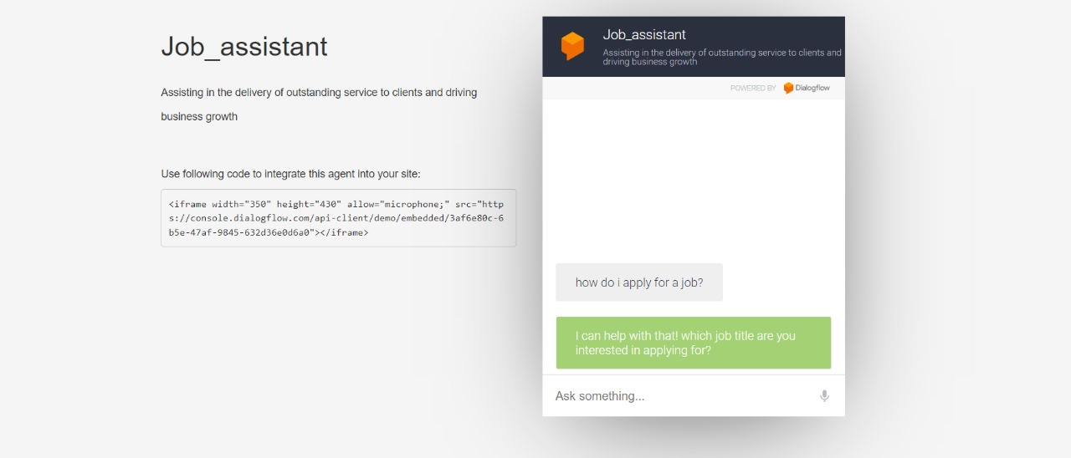

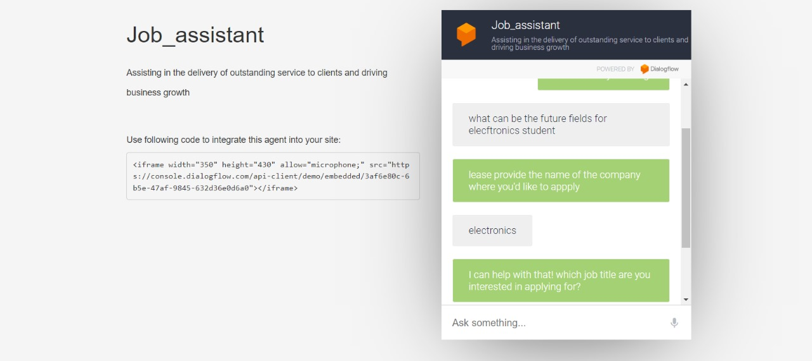

This image shows the user interface of the AI job assistant chatbot. The chatbot is designed to assist users in various job-related tasks, such as:

* **Job Search Assistance**: Users can input their preferences, and the chatbot retrieves job listings that match their criteria.
* **24/7 Availability**: The chatbot operates continuously to help users anytime they need.

The interface is designed with a clean, user-friendly layout, including input fields, response bubbles, and interactive buttons for ease of use. It is accessible on both desktop and mobile platforms, ensuring flexibility for different user environments.

**Methodology**

The development process of the AI Job Assistant Chatbot was structured and executed in several key phases, each contributing to the final product. The methodology is outlined as follows:

1. **Problem Understanding and Requirement Gathering:**
   * Defined the problem: Assisting job seekers in job search, resume preparation, and interview guidance.
   * Collected user requirements from job seekers and recruiters.
   * Identified key chatbot functionalities: job recommendations, resume parsing, and interview preparation.
2. **Data Collection and Preparation:**
   * **Job Listings Data:** Gathered data from APIs like LinkedIn, Indeed, and Glassdoor.
   * **Resume Data:** Collected sample resumes to train the resume parsing feature.
   * **FAQ Data:** Collected frequently asked questions related to job search and interviews.
3. **Model Development:**
   * **Job Matching Algorithm:** Trained a job recommendation model using classification algorithms to match users to relevant job listings.
   * **Q&A System:** Developed a question-answering model using pre-trained GPT to handle common job-related queries.
4. **Chatbot Development:**
   * **Framework:** Built the chatbot using Dialogflow for conversation management and intent recognition.
   * **API Integration:** Connected the chatbot to LinkedIn API for job listings and resume parsing APIs for user-uploaded resumes.

**Project Outcomes**

• Automated job search assistance with real-time, personalized job recommendations based on user’s profile.

• Accurate job matching based on user profiles, skills, and preferences.

• Real-time interview preparation assistance, including answering FAQs and offering tips.

• Enhanced user engagement through an easy-to-use interface and multi-platform accessibility.

• Continuous learning and improvement through regular model updates and data integration.

• Increased efficiency for HR professionals and job seekers by automating key recruitment tasks.

• Iterative improvements based on user feedback, enhancing the chatbot’s performance and usability.

• Resume parsing and personalized feedback for improving job application success.

• Effective job matching using machine learning algorithms, improving recommendation accuracy.

**Lesson learned**

1. **Understanding User Needs and Use Cases**

* Lesson: Identifying the specific needs of users (job seekers, recruiters, HR professionals) is crucial for developing a chatbot that provides meaningful assistance.
* Takeaway: Engage in user research and feedback loops to refine features and improve user experience.

2. **Natural Language Processing (NLP) Challenges**

* Lesson: Designing an AI that can handle different user intents, understand varied inputs, and provide accurate, context-sensitive responses is complex.
* Takeaway: Learning to work with NLP frameworks (e.g., dialogflow).

3**. Handling Ambiguity and Contextual Understanding**

* Lesson: Users may phrase the same request in many different ways. The chatbot must handle ambiguity, misinterpretations, and maintain context across conversations.
* Takeaway: Incorporate intent recognition, entity extraction, and context management strategies for better conversational flows.

4. **Integration with External Systems**

* Lesson: Connecting the chatbot to databases, job boards, or applicant tracking systems (ATS) is essential for it to function as a job assistant.
* Takeaway: Experience in APIs, cloud services.

**5. Conversational Design and User Experience**

* Lesson: Creating a natural and engaging dialogue flow, while balancing the bot's functional and conversational aspects, is challenging.
* Takeaway: Apply user-centred design principles, leveraging tools like conversation trees and feedback loops to improve interaction.

**6. Collaboration and Team Dynamics**

* Lesson: Developing a chatbot is a collaborative effort that involves working as freshers .
* Takeaway: Experience in cross-functional teamwork, project management, and agile methodologies.

**7. User Feedback and Iteration**

* Lesson: User feedback is essential for identifying limitations and enhancing features.
* Takeaway: Develop a cycle of deploying, testing, gathering feedback, and iterating to improve the chatbot continuously.

**8. Ethical Considerations**

* Lesson: Ethical issues like bias in job recommendations, fairness in suggestions, and transparency in how decisions are made are critical.
* Takeaway: Understand AI ethics and ensure fairness, accountability, and transparency in AI systems.

These lessons reflect both technical and non-technical aspects, ensuring a more comprehensive understanding of what it takes to create a functional and user-friendly AI job assistant chatbot.

**Future scope**

The future scope of making the AI job assistant chatbot includes:

1. Advanced Personalization (tailored job recommendations, skill gap analysis)
2. Multilingual Support (language expansion, real-time translation)
3. AI Bias Mitigation (fairness in job recommendations, ethical AI)
4. Integration with More Platforms (job boards, professional networks, ATS)
5. Proactive Job Search Assistance (automated job alerts, application assistance)
6. Smart Interview Preparation (mock interviews, interview feedback, soft skills training)
7. Career Path Guidance and Upskilling (career growth analysis, upskilling recommendations)
8. Real-time Resume Feedback (automated scoring, ATS optimization)
9. Data-driven Job Market Insights (real-time trends, salary negotiation assistance)
10. User Emotion
11. Enhanced Analytics for Employers (job posting effectiveness, candidate match scores)
12. Cross-industry Expansion (industry-specific job assistant chatbots)

**Conclusion**

During the course of this internship, the development of the AI Job Assistant Chatbot has demonstrated both the potential and complexities of applying artificial intelligence in a real-world job-seeking context. The project successfully achieved its primary objectives by delivering a functional chatbot that assists users with common job-related queries, such as job search, resume review, and interview preparation, while showcasing the power of natural language processing (NLP) and machine learning.

**Key Achievements**

1. Functional Deployment: The chatbot was effectively deployed with the ability to understand and respond to various user inputs. This included job recommendations, resume evaluation, and interview tips, based on user-provided information.
2. NLP Implementation: By utilized NLP models, the chatbot demonstrated the capacity to process and respond to natural language queries, enabling smooth, user-friendly interactions.
3. API Integration: Integration with external job databases and other systems allowed the bot to provide real-time job listings and recommendations, adding real value for job seekers.
4. Iterative Improvements: A feedback-driven approach enabled continuous improvement of the chatbot’s performance, helping it become more accurate and user-friendly over time.

**Challenges Overcome**

Despite the success, the project encountered several challenges, particularly in dealing with ambiguous user queries and maintaining context throughout conversations. Additionally, integrating multiple APIs and ensuring data privacy and security were critical hurdles that required careful consideration and robust implementation. Addressing these challenges has expanded our knowledge of both technical and ethical AI considerations.

**Lessons Learned**

1. The importance of user-centred design in crafting chatbot responses to ensure relevance and clarity.
2. Context management was essential to maintain the flow of conversation, especially in longer user interactions.
3. Building a chatbot that handles edge cases gracefully and learning to manage unexpected inputs were valuable experiences.
4. Data privacy and compliance with security protocols are paramount, especially in handling sensitive job-related information.

**Future Scope**

While the chatbot provides a solid foundation, there remains significant scope for further enhancement:

* Advanced Personalization: Future iterations could benefit from deeper personalization, tailoring job recommendations more effectively based on individual profiles and preferences.
* Multilingual Support: Expanding to support multiple languages would broaden the user base and accessibility.
* AI Bias Mitigation: Continuous effort is needed to minimize any potential biases in job recommendations or other AI-driven decisions.

**Final Thoughts**

In conclusion, the AI Job Assistant Chatbot project not only provided valuable learning opportunities in AI and NLP technologies but also revealed the complexities of creating a system that addresses the dynamic and nuanced needs of job seekers. The successful development and deployment of the chatbot illustrate how AI can streamline job search processes and improve the user experience. The knowledge and skills gained from this project, including collaboration, innovation, and problem-solving, will be highly beneficial in future AI and machine learning initiatives.

**References**

**•** Google Search Data  
 *Google Search Engine*. Retrieved from [<https://www.google.com>]

• LinkedIn API and Job Listings  
 *LinkedIn Developers API*. Retrieved from [<https://developer.linkedin.com>]  
LinkedIn. (n.d.). *LinkedIn Job Listings*. Retrieved from [<https://www.linkedin.com/jobs>]

• Internshala Data - *Internshala Job Listings and Internship Opportunities*. Retrieved from [<https://internshala.com>]

• ChatGPT Assistance  
OpenAI. (2023). *ChatGPT Language Model*. Available from [<https://chat.openai.com>]

• YouTube Tutorials - Various tutorials on AI chatbot development and job search algorithms were consulted.

Thank you

Your sincerely

Shruti Baranwal

Vartika